End point URL

http://image-filter-starter-code-dev2.ap-south-1.elasticbeanstalk.com/filteredimage?image_url=https://image.shutterstock.com/z/stock-photo-san-francisco-california-november-th-the-sign-outside-jp-morgan-chase-co-on-mission-750526441.jpg

Original Image

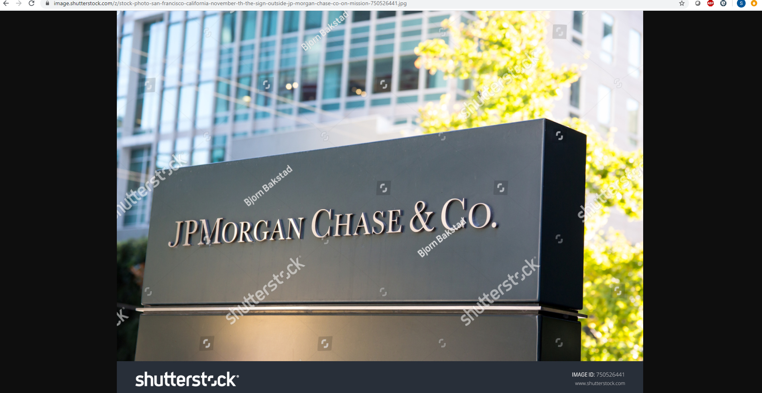

Filtered Image

